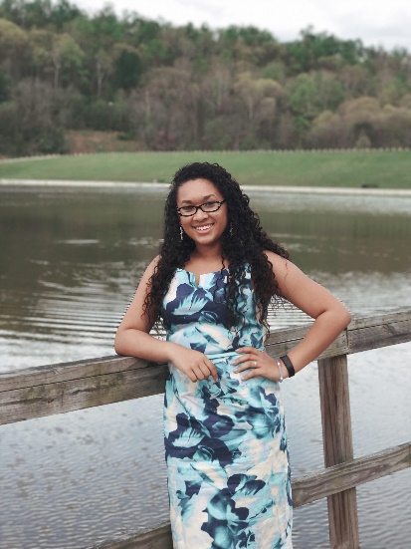
D.C Experience
By Cheri Duckwyler
My experience at the Holocaust will forever be memorable. However, this is not my first time visiting. I previously went back in June of 2016 with an educational program. We had just finished reading the book Night by Elie Wiesel. The only prior knowledge was of which everyone knows, the basic knowledge. Walking through the museum for the first time, I was overwhelmed with facts that I couldn’t take in. Instead I decided to pay closer attention to the details of pictures, displays, objects, etc. Rather than knowing the facts of the holocaust, I wanted to know what it felt like. The display of the pictures that sit several feet tall showed me that these people weren’t just a number but someone’s family and friends. The voices I heard in Auschwitz, real voices, I felt like I was there, listening to them in person. After I walked out of the museum, I felt different. Even though I didn’t come out with facts, I came out with a different heart.
The following school year, I decided to dive deeper into my learnings and take the College Holocaust class. We were able to have the opportunity to visit the museum as a class. Walking into the museum for a second time was absolutely breath taking. After taking the class, I was able to walk in there with more knowledge I did the last time I came. I felt more connected and had more respect and pride for what was being offered in the museum. From floor to floor, I looked at the videos I wasn’t able to look at before and pictures that were too gruesome to see several months ago. My knowledge of the class came flooded back at once and I was able to add to the information that was already given to me. Some things cannot be taught in the classroom. You have to see it with your own eyes in order to go in deeper in the studies of the Holocaust and that is what I got out of seeing this museum. Seeing this museum once or twice is not enough for me. You can learn something new every visit. The more knowledge you have, the more your perspective changes on things. My second walkthrough, I found things that didn’t affect me the first time as it did the second and I believe I owe that all to the gain of knowledge from this class. I am still learning and want to continue learning. Hopefully I will be able to visit the Holocaust Museum at least one more time. I want to thank all the people who were able to make my experience at both visits of the museum possible. Without them I wouldn’t be the person I am today.

